**Project Report**

Gui Test Report

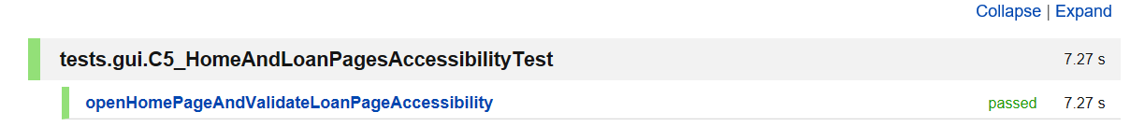

Backend Test Report

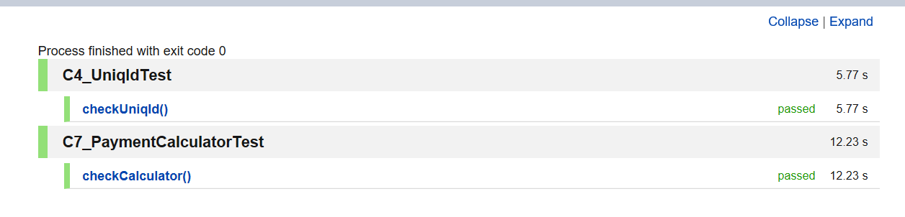

Performance Test Report



Bugs Opened

12

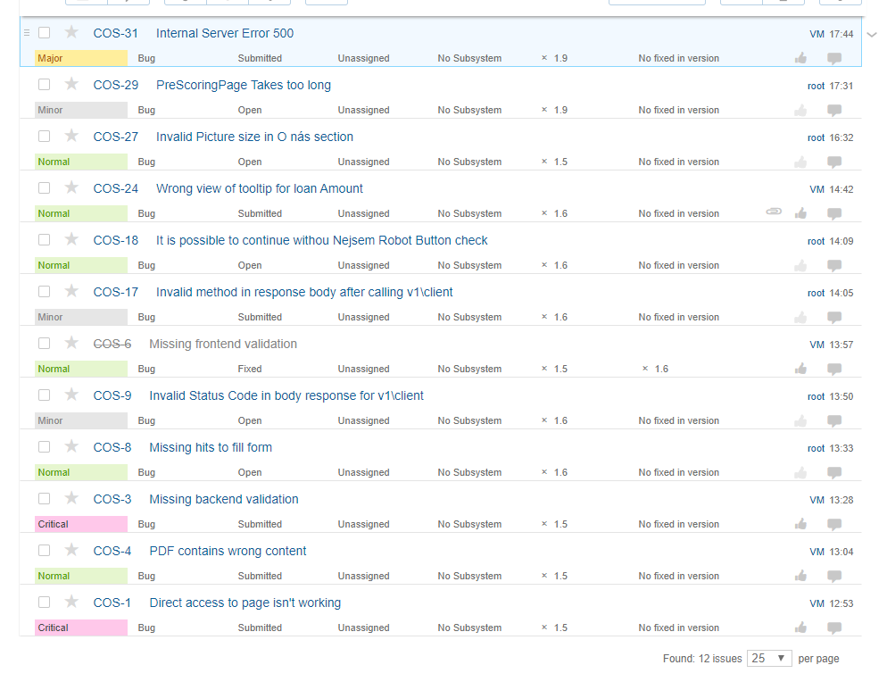

Bugs Closed

4

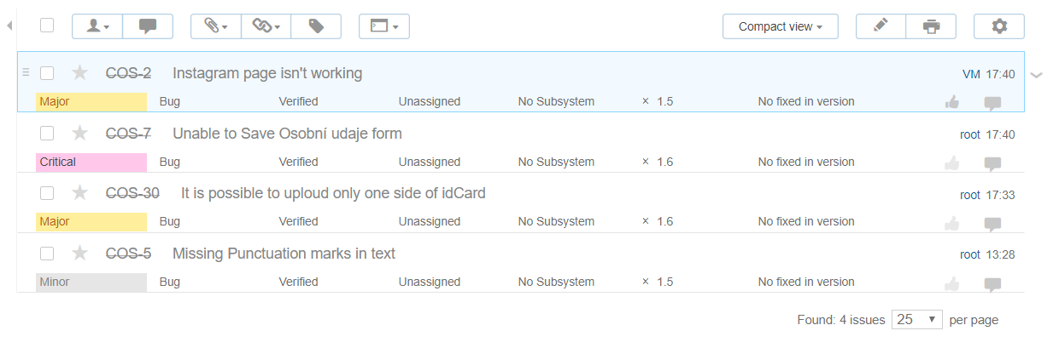

Enhancement Opened

3

Enhancement Closed

6